- Reviewer
(1)First , you would receive an email informing you that you are chosen to be a reviewer of a certain article , then you should log in the Euromarketing website to decide whether or not to do the review work ..
(2) If you decide to do it ,you click the label underneath the REQUEST button in the Review Steps part to inform the editor that you will do the review work .and then begin the review process .

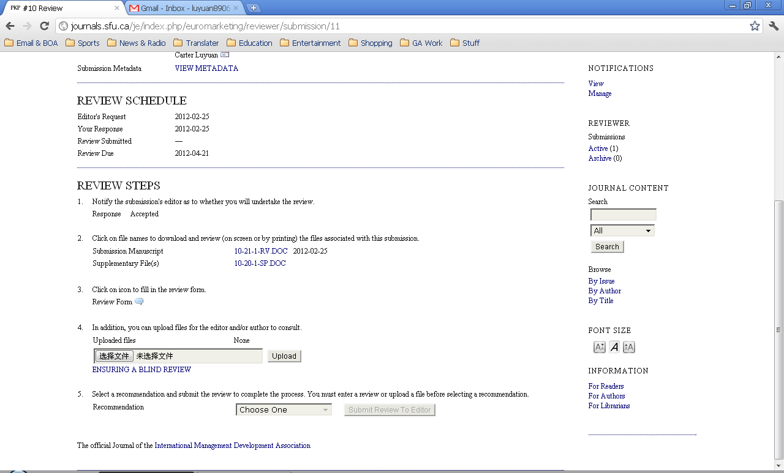 (3) Moving to Review Step 2, reviewer can download the review article by simply click its name , and then review the article .
(4)After reviewing , reviewer should go through Review Step 3 , filling out the review form .
(5)Then you can upload reviewed files by going through Review Step 4
(6)Then you will go through the last step , Review Step 5 , to decide whether to accept the submission . When you done ,remember to click the button “Submit Review to Editor” . After that , the review process is done
