- Editor
- When an editor logs in , this interface would show up . The editor click the “In Review ” button and then click the Title Name you want to review to begin the review process .
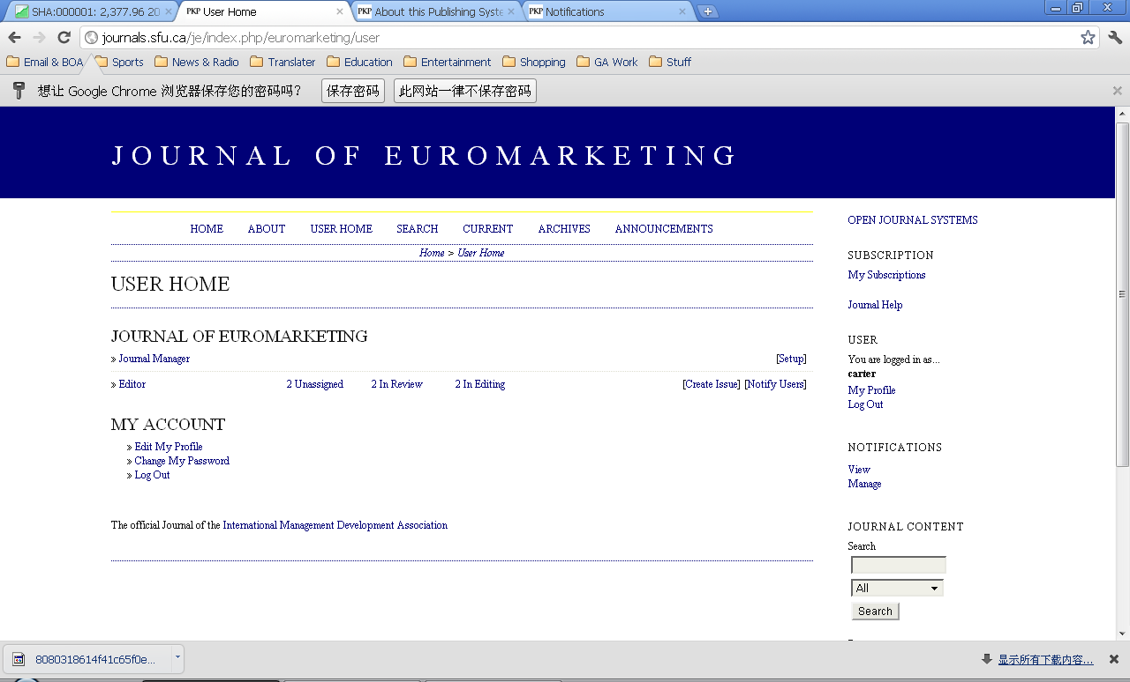
(2) Then the editor should first click “Present the file to reviewer ” and Record in the submission part , and then click “Round 1 Select Reviewer ” button.. In this case , we have three reviewers . And then , the editor should reach editorial decision .
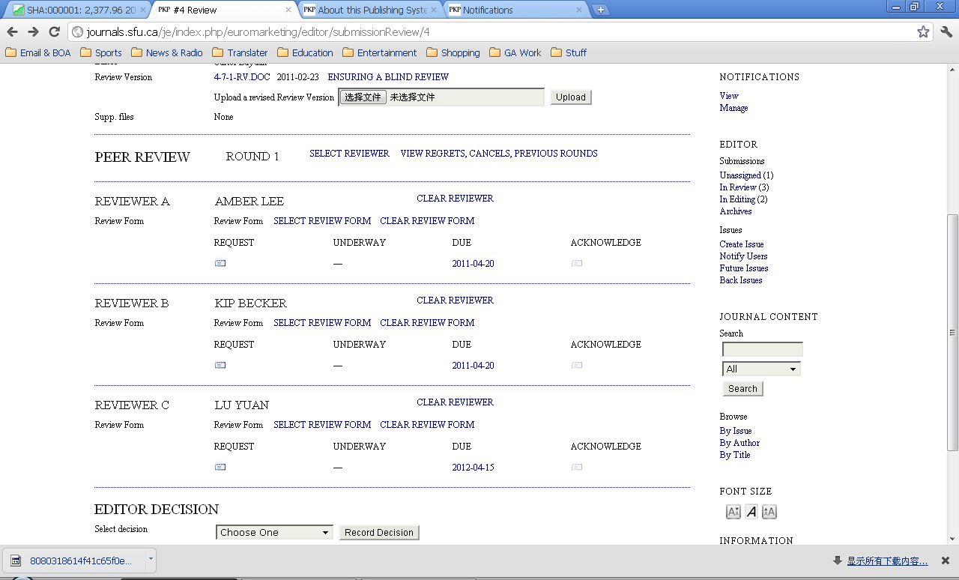
(3)Then , the editor should click the label underneath the REQUEST ,.send an email to each reviewer to inform them that they have been chosen to review certain articles.
(4)Then , after reviewers confirm that they will to the review work , editor should click the button “Will Do the Review ” .
(5)If every reviewer agree to Accept Submission , editor should select “Accept Submission ” and click Decision Record in the editor decision part . Then , editor should make adjustments according to reviewers’ options , and ultimately come out to a final version which is used to publish .
(7)Then the editor should inform the author, by clicking the button “Send to Copyediting ” , that his or her original article has been adjusted . After that . editor should upload the final version .
(8)After the submission process is done , editor would receive a message in View , editor can view all the information about the submission .
(9) Then the editor should go to “Scheduling ” part in the Editing page , choose which issue to publish in.
(10)If you want to create a new issue , just click “Create Issue” in the front page , remember to click “publish ” when you done .
(11)Then , the editor can offer immediate open access or delayed open access with subscriptions . After that , complete records kept of submission process for published and declined items . Thus , the editor’s job is done .

