All authors , editors and reviewers must be assigned by managers beforehand .

- Author
(1) When an author logs in , this interface would show up . If you want to submit a file , go to the Start A New Submission , and click “ Click Here”
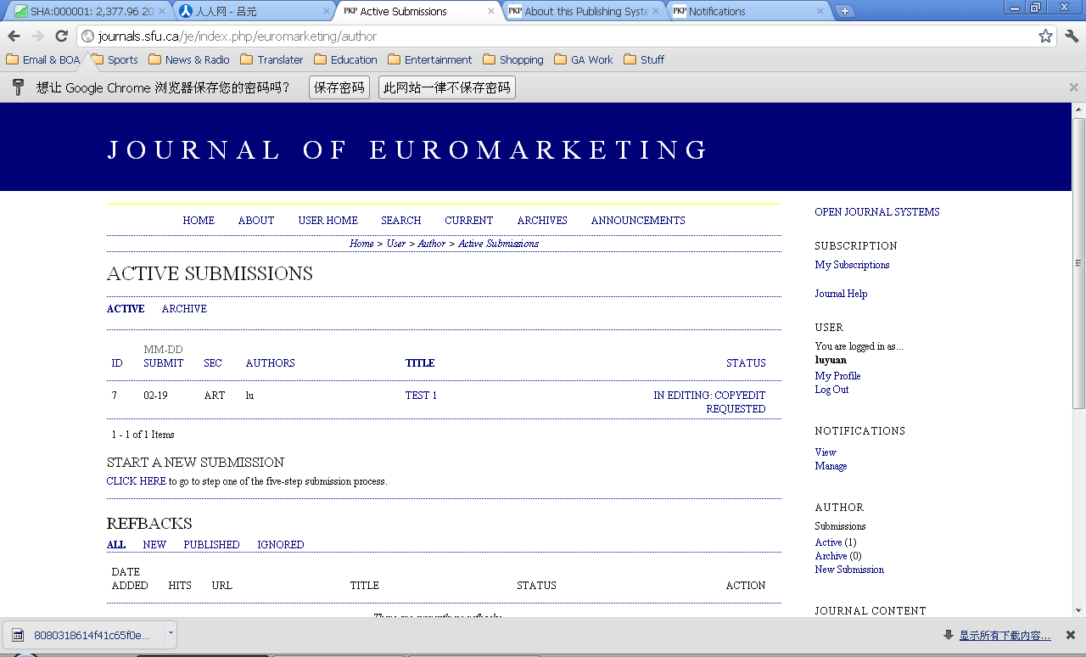

(2) Then you will go through step 1 “Start ” . In the Journal Section part, choose “Article” , and you should fill out all the checklist in the Submission Checklist part.
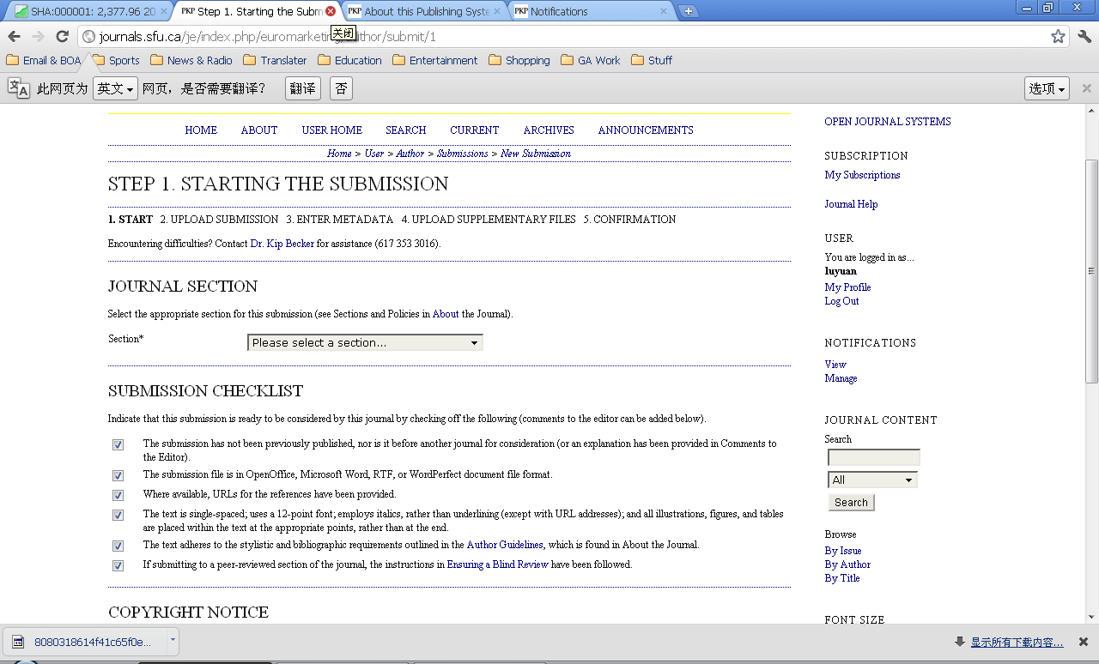
(3)Then you will go through step 2 “ Uploading the Submission ” . Remember to click upload when you submitted .
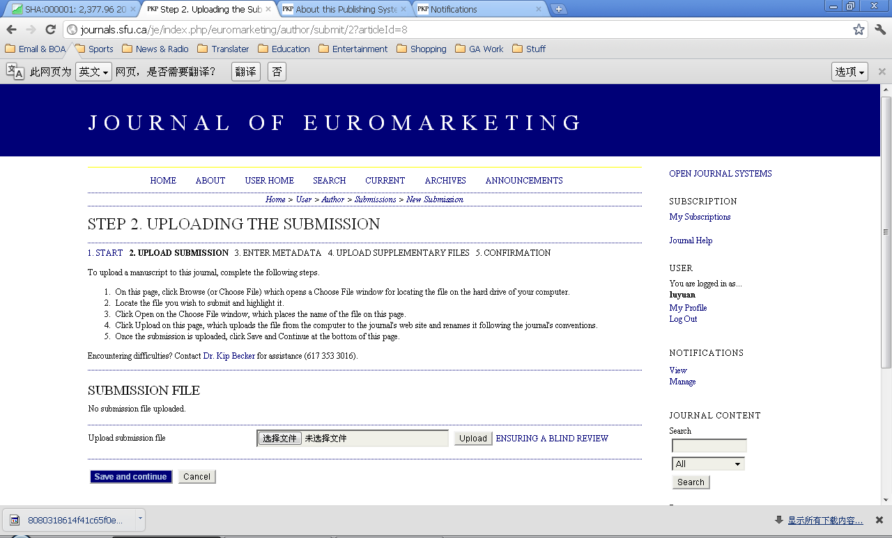
(4)Then you will go through step 3 “Entering the Submission Metadata” . Please fill out all necessary information .
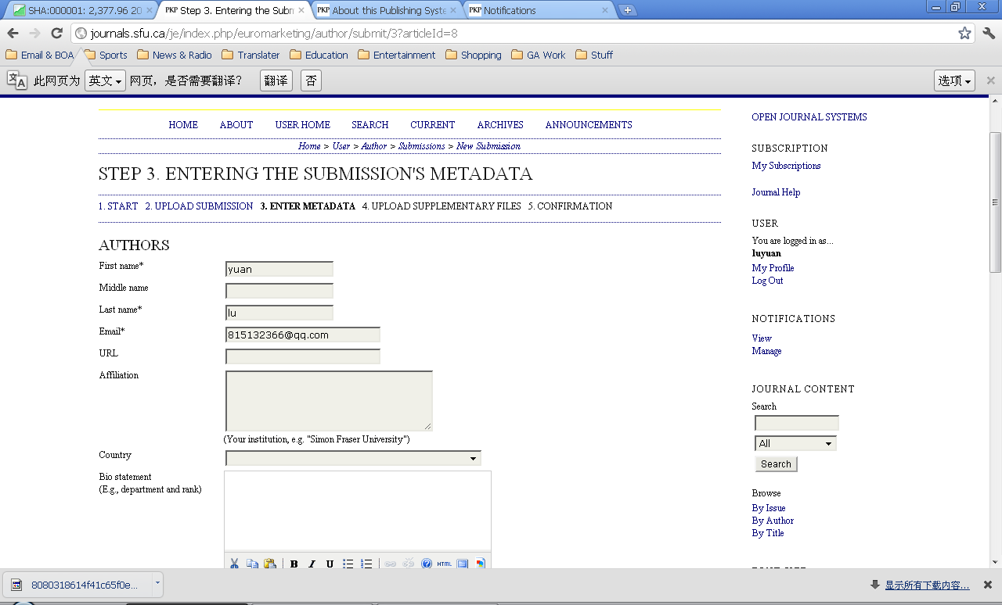
(5)Then you will go through step 4 “ Uploading Supplementary Files” .Whether or not upload a supplementary file is your choice . If you choose to submit another one , remember to click “upload” after you submitted .
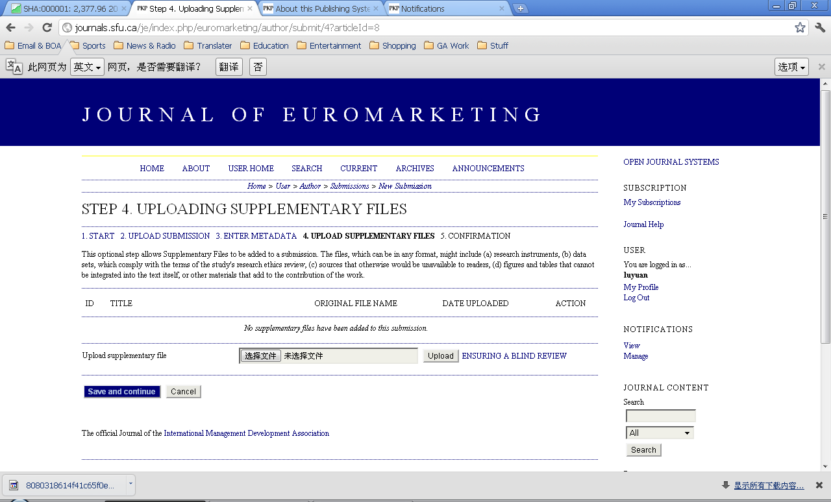
(6)Then you will go through step 5 “Confirming the Submission ” . Shortly after you click the “Finish Submission ” button , you will receive an email informing you that you have successfully submitted your file .
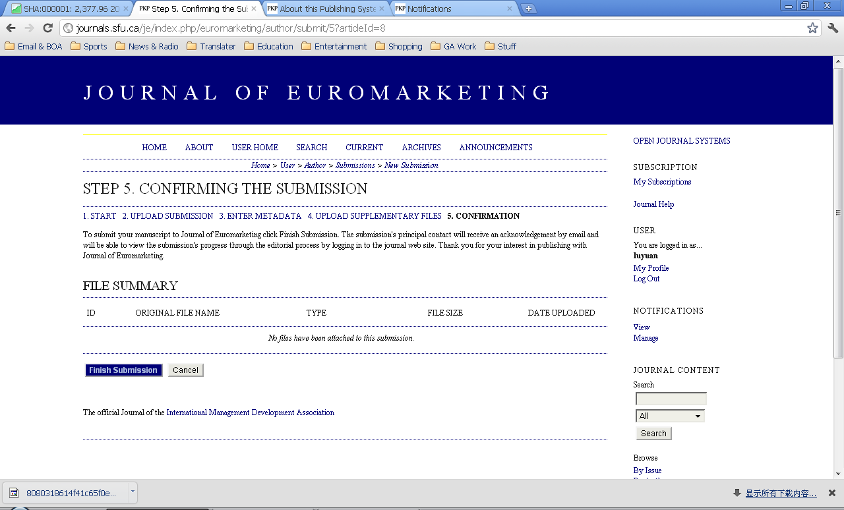
After this , the whole process is done , the submission is in the Active List and the author should wait for submission review .During this time , the author can track process ,see files , reviews ,revise and resubmit . After review, the author reviews copyedits and proofreads galleys .

